Q-Q Plot Worksheet – Questions and Answers
Name: Yashika R Reg. No.: 192525102
Instruction: For each normal Q-Q plot, decide whether the data appear normal and identify the shape using the given categories.
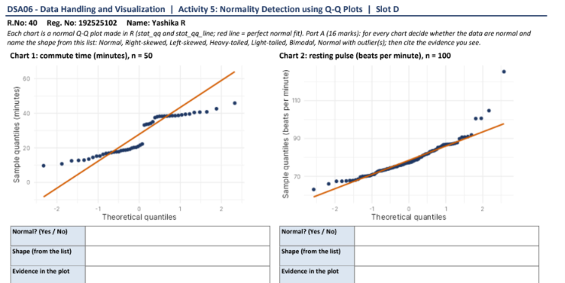
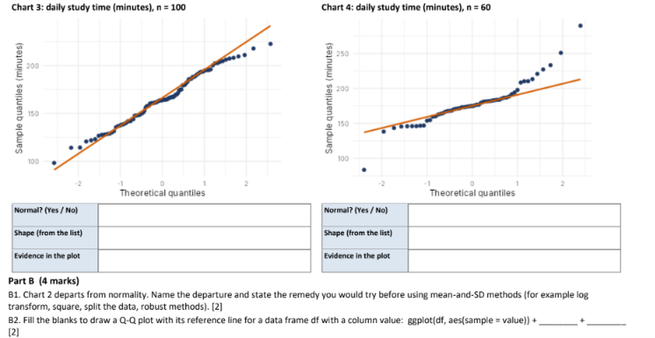

Chart 1: Commute time (minutes), n = 50
Normal? (Yes / No) | No
Shape (from the list) | Bimodal
Evidence in the plot | The points form a noticeable curved/step-like pattern instead of following the straight reference line, suggesting two clusters or peaks.

Chart 2: Resting pulse (beats per minute), n = 100
Normal? (Yes / No) | No
Shape (from the list) | Right-skewed (heavy upper tail)
Evidence in the plot | Most points follow the line in the middle, but the upper-right points bend well above it, showing a long upper tail and unusually high values.

Chart 3: Daily study time (minutes), n = 100
Normal? (Yes / No) | Approximately yes
Shape (from the list) | Approximately normal
Evidence in the plot | The points lie close to the straight reference line across most of the plot, with only small departures at the ends.

Chart 4: Daily study time (minutes), n = 60
Normal? (Yes / No) | No
Shape (from the list) | Right-skewed, with an unusually low value
Evidence in the plot | The points curve above the reference line in the upper tail, with several high values; one point at the lower-left is also far below the line.

Part B (4 marks)

B1. Chart 2 departs from normality. Name the departure and state the remedy you would try before using mean-and-SD methods. (2 marks)
Answer: Chart 2 is right-skewed, with a heavy upper tail and a few unusually high pulse values. I would try a log transformation (if appropriate for the data) and then check the Q-Q plot again. If the skewness or extreme values remain, I would use robust methods such as the median and interquartile range instead of relying only on the mean and standard deviation.

B2. Fill in the blanks to draw a Q-Q plot in ggplot. (2 marks)
Question: ggplot(df, aes(sample = value)) + ______ + ______
Answer: ggplot(df, aes(sample = value)) + stat_qq() + stat_qq_line()

Note: The chart classifications are based on the visible Q-Q plots; Chart 3 is treated as approximately normal because its points mostly follow the reference line.

